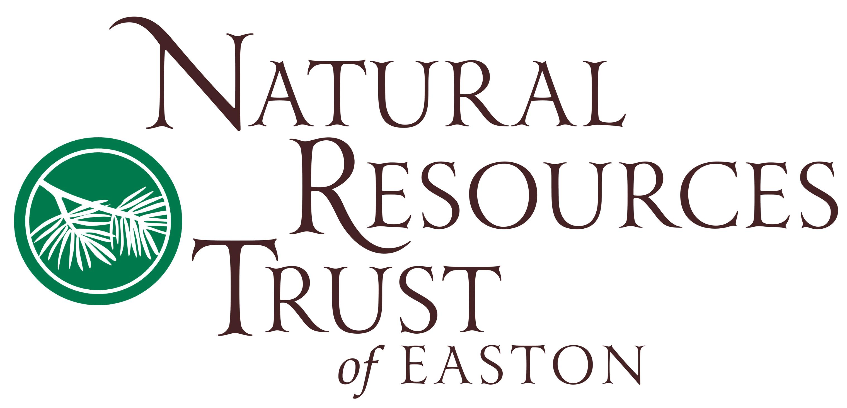
NRT Project Application for Eagle Scout and Long-Term Projects @ NRT
Current Date:
Project Deadline:
Project applications can be completed and emailed to info@nrtofeaston.org or mailed to: NRT Community Projects Program, Jennifer Cummings, Director, PO BOX 188, N. Easton, MA 02356.
This form must be submitted prior to meeting with NRT staff regarding project planning. Completing this form does not indicate permission to begin any project. If additional space is needed for any question, please use an extra sheet or create a separate word document and attach to email if needed.
1. Contact and Emergency Information
Name (Last, First, MI): |  |  |  |  | Date:
Present street address: |  |  | City: State: Zip:
Permanent street address: |  |  | City: State: Zip:
Cell phone: | Current year of schooling (F,S,Jr,Sr.)? |  |  | E-mail address:
In case of emergency, please contact: (name and phone) |  | Are you less than 18 years of age?  Yes No  Date of birth:
High school graduate: Yes No  Date/ expected date of graduation:  College graduate: Yes No  Date/ expected date of graduation:  Major: |  | Please indicate the topic of project you are seeking:  Environmental Education (teaching)  Environmental Science (applied research)  Environmental Science (other): please specify area of interest:  Outdoor construction: please specify:  Other: _____________________________________
Are there any personal medical conditions (significant allergies, conditions, etc.) NRT staff should be aware of during your work on NRT property, in case of emergency? |  | If applicant is under 18:  Name(s) of parent/guardian:  Cell/phone:  Email:  All personal and contact information will be held as confidential by NRT staff involved with the project and shared only on an emergency basis if needed.

2. Education
List the high school and/or college you have attended, beginning with your most recent: (if applicable)
Name of School or Organization | Location | Dates Attended | Years Completed

3. Previous Internships and Employment
Provide a list of previous employers or volunteer opportunities completed. Please include all paid and unpaid positions in the order they occurred. If none, please write ‘none’. Please continue list on separate sheet of paper if needed.
Internship or Employer | Address | Dates of Employment | Position Held
1. Company: | Address: | From: To: | Title:
Duties performed: |  |  | Supervisor:
2. Company: | Address: | From: To: | Title:
Duties performed: |  |  | Supervisor:
3. Company: | Address: | From: To: | Title:
Duties performed: |  |  | Supervisor:
4. Company: | Address: | From: To: | Title:
Duties performed: |  |  | Supervisor:
5. Personal & Project Goals
Please describe your personal goals and why you are hoping to complete a project at NRT.

6. Personal Educational Benefit
Please indicate what you hope the personal learning outcome of this opportunity will be.

7. Internship Focus:
Before meeting with NRT staff, the applicant should have 2-3 ideas of projects they would like to focus on during their experience, based on their resources, project requirements, and personal interest. NRT staff will not provide complete projects to students. Please briefly share your ideas below. Final project guidelines will be decided between the student and cooperating NRT staff supervisor to meet the needs of the project and the NRT. All projects must compliment the mission of the NRT.

8. Availability
What are the expected starting and ending dates of your project? (Estimate if needed)

What time(s) and day(s) of the week are you available? Please note weekend dates may be limited, and holidays are often not available. For liability reasons, NRT staff are required to be on site during project completion.

9. References
Please give the name, email, and phone of your cooperating supervisor for this experience:

10. CORI/SORI Background Checks

If internships involve working independently with children during NRT programs, interns may be required to submit to CORI and SORI background checks. Do you understand that background checks may be required as a condition of your internship/project?
Yes No

11. Other: Is there any other information you would like to share with NRT regarding your potential project?

12. Application Verification

THIS FORM IS NOT VALID WITHOUT YOUR SIGNATURE. PLEASE READ IN ENTIRETLY BEFORE SIGNING:

All volunteer experiences must receive prior approval from both the cooperating school, college, organization, or institution, and the NRT. No project or internship may begin without approval of both organizations. All internships/project opportunities at NRT are unpaid and are offered in cooperation with the applicant’s school, organization, or college in order to fulfill learning requirement(s). Interns or volunteers are not employees of NRT at any time.

Any credits, grades, or applicability toward recognition are the sole responsibility of the applicant and the cooperating school, organization, or college. If accepted, the volunteer is solely responsible for communicating, planning, completing, and submitting all program requirements to his/her organization. The NRT and its staff hold no responsibility for the applicant’s successful completion of the project or internship experience.

I understand and accept the requirements of the NRT and my sponsoring organization. The statements above are true to the best of my knowledge.

Signature Date

